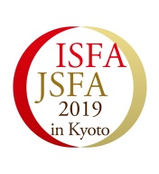
BOOKING FORM FOR SPONSOR ITEMS
ISFA & ISFA 2019 17-20 October, 2019 Kyoto, Japan
Exhibitions

INVOICE ADDRESS
Name of company
Contact person
Address
City
Phone
Zip Code
E-mail
Fax

We would like to book the following Sponsor items:
ITEMS |  | CHECK | PRICE(USD)
Exibition | Booth
 |  | Total
Exhibition Contents

Application deadline
Deadline for the Exhibitors is 30/June/2019

Terms of Payment
Total sponsorship fee will be invoiced after this signed Sponsorship Booking Form has been received. Term of payment will be announced on the invoice.

Signature of this form implies compliance with the rules stated in this document.

Signature: Date:

This application is legally binding
Return to Attn: ISFA2019, Miwa Kunishima
mail: isfa.kigyo@atalacia.com

